Executive Summary: Marketing Campaign Analysis
SkillCraft Technology
Submitted by: Swathi M K | Data Analyst Intern
The Bottom Line
The campaign secured 7,012 conversions across 8,000 customers. While Social Media drove the highest volume, PPC offered the best financial efficiency. To improve the current 4.74% average ROI, the budget should shift toward high-income demographics and performance-heavy channels.
Channel Performance Breakdown
- Best for Growth: Social Media (Highest conversion rate).
- Best for Profit: PPC (Highest ROI).
- Underperformer: Email Marketing (Low efficiency; needs optimization).
- Key Trend: Diminishing Returns—higher spend does not always equal better results.
Customer Profile
- Primary Driver: Income level is the strongest predictor of conversion. High-income segments represent the highest conversion probability.
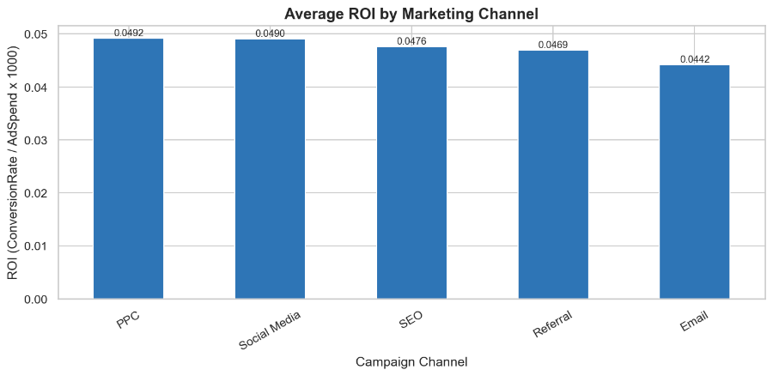
Visualization

Action Plan
- Pivot: Increase PPC and Social Media investment.
- Refine: Optimize Email content or reduce its current budget.
- Target: Focus ad sets on high-income customer segments to capture higher value.

